The Help Me Grow System of Supports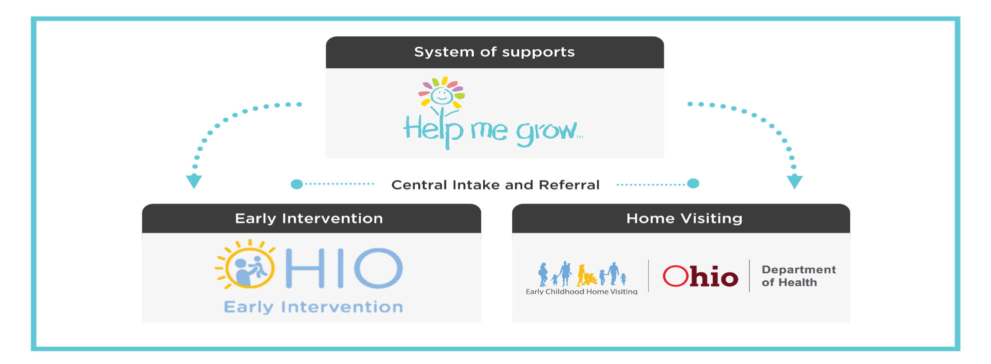

Central Intake and Referral

In 2018, Bright Beginnings was selected by the Ohio Department of Health and the Ohio Department of Developmental Disabilities to be the single point of entry for the Help Me Grow system of supports. The Pike County Board of Developmental Disabilities is the Southern Region’s partner covering 12 counties including Athens, Fairfield, Gallia, Hocking, Jackson, Lawrence, Meigs, Pickaway, Pike, Ross, Scioto, and Vinton. * link for button above https://www.helpmegrow.org/Default.aspx

As the Help Me Grow Central Intake & Referral contractor for the Southern Region, Pike County Board of DD connects pregnant women, caregivers with new babies, and families with young children with developmental delays and disabilities throughout region to the services and supports provided through Home Visiting and Early Intervention.

Home Visiting supports pregnant women and new parents with the tools and information they need to nurture the healthy growth of their child through the earliest years.

Early Intervention works with families with children birth to age 3 who have developmental delays or disabilities so that they have the best possible start in life. Anyone can refer a child if you have concerns that a child has a delay or disability.

Refer a family for Home Visiting or Early Intervention
Anyone can refer a family to Help Me Grow. There are several different ways to make a referral:
- Complete the online referral form
- Call 1 (800) 755-GROW to speak with an Intake Specialist
- Find regional contact information https://www.helpmegrow.org/Refer.aspx
- Email completed forms to HMGReferrals@helpmegrow.org
- Print and fax referral forms to (855) 318-3322 or (855) 418-3322

Outreach to Professionals and Families
As a regional partner, Pike County Board of DD provides outreach to families and referral sources by attending local events, sharing information about service options, and presenting to professionals on the benefits of Home Visiting and Early Intervention. To request participation at a local event, marketing materials, and/or a presentation about Early Intervention, Home Visiting, or the Help Me Grow system of supports, email Melissa Hutton, Outreach Specialist at melissa.hutton@pikeboarddd.org

Help Me Grow
Central Intake and Referral
Southern Region

(740) 371-3322

Contacts

Stephanie McDowell
Contract Manager
P: (740)261-9495 Email: stephanie.mcdowell@pikeboarddd.org

CJ McDowell
Lead Central Intake & Referral Specialist
P: (740)261-9553 Email: chrystal.mcdowell@pikeboarddd.org

Trent Noble
Central Intake & Referral Specialist
P: (740)261-9554 Email: trent.noble@pikeboarddd.org

Paula Perkins
Central Intake & Referral Specialist
P: (740) 261-9555 Email: paula.perkins@pikeboarddd.org

Melissa Hutton
Outreach Specialist
P: (740) 261-9556 Email: melissa.hutton@pikeboarddd.org

